Main Task API Control Instagram Comment Task Example
1. First, create a comment task in the Instagram platform tasks, as shown below. 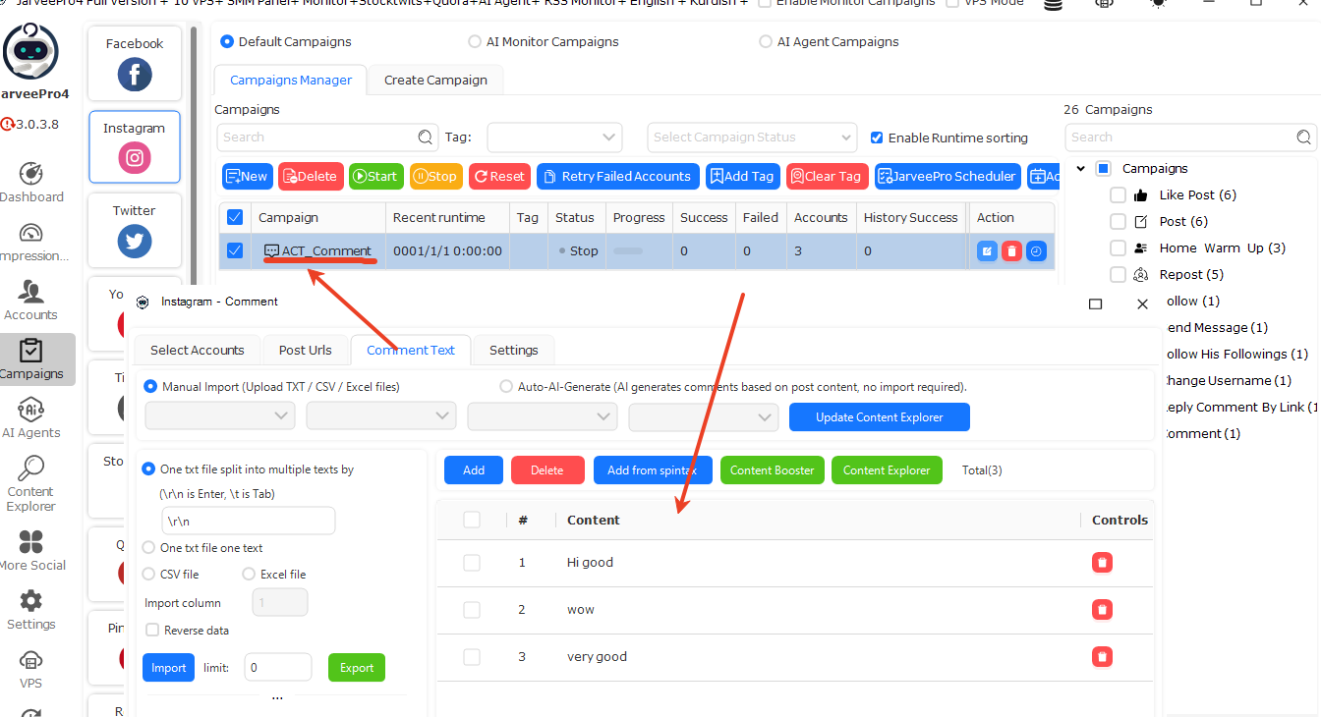
2. After it is created, we query the task we just created through the API interface. The query parameter example is as follows.
{"Platform":1,"Type":19,"Data":{"PageIndex":0,"PageSize":20,"PageTotal":0,"CountTotal":0,"SearchData":"ACT"}}
Since the task name contains the keyword ACT, we can include this keyword in the query to retrieve the specified data, as shown in the figure.

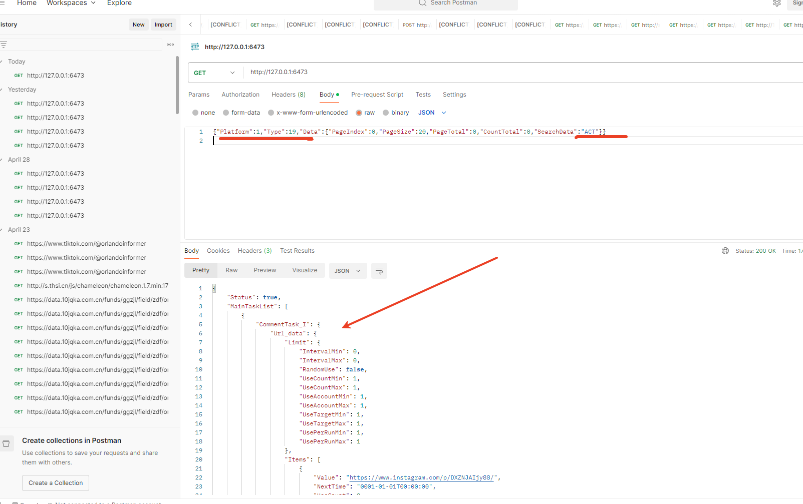

{
"Status": true,
"MainTaskList": [
{
"CommentTask_I": {
"Url_data": {
"Limit": {
"IntervalMin": 0,
"IntervalMax": 0,
"RandomUse": false,
"UseCountMin": 1,
"UseCountMax": 1,
"UseAccountMin": 1,
"UseAccountMax": 1,
"UseTargetMin": 1,
"UseTargetMax": 1,
"UsePerRunMin": 1,
"UsePerRunMax": 1
},
"Items": [
{
"Value": "https://www.instagram.com/p/DXZNJAIjy88/",
"NextTime": "0001-01-01T00:00:00",
"UseCount": 0,
"AccountUseCount": {},
"TargetUseCount": {}
},
{
"Value": "https://www.instagram.com/p/DXtvzoHDse5/",
"NextTime": "0001-01-01T00:00:00",
"UseCount": 0,
"AccountUseCount": {},
"TargetUseCount": {}
},
{
"Value": "https://www.instagram.com/p/DXEggDKAVza/",
"NextTime": "0001-01-01T00:00:00",
"UseCount": 0,
"AccountUseCount": {},
"TargetUseCount": {}
}
],
"ListData": false,
"Probability": 100,
"Count": 3
},
"Comment_data": {
"Limit": {
"IntervalMin": 0,
"IntervalMax": 0,
"RandomUse": false,
"UseCountMin": 1,
"UseCountMax": 1,
"UseAccountMin": 1,
"UseAccountMax": 1,
"UseTargetMin": 1,
"UseTargetMax": 1,
"UsePerRunMin": 1,
"UsePerRunMax": 1
},
"Items": [
{
"Value": "Hi good",
"NextTime": "0001-01-01T00:00:00",
"UseCount": 0,
"AccountUseCount": {},
"TargetUseCount": {}
},
{
"Value": "wow",
"NextTime": "0001-01-01T00:00:00",
"UseCount": 0,
"AccountUseCount": {},
"TargetUseCount": {}
},
{
"Value": "very good",
"NextTime": "0001-01-01T00:00:00",
"UseCount": 0,
"AccountUseCount": {},
"TargetUseCount": {}
}
],
"ListData": false,
"Probability": 100,
"Count": 3
},
"commentUrlSave": {
"SaveToFile": false,
"JoinString": "\\r\\n",
"FilePath": ""
}
},
"Results": [],
"AutoTryNum": 0,
"StartTime": "0001-01-01T00:00:00",
"StopTime": "0001-01-01T00:00:00",
"IsMcsTask": false,
"IsPublicMcsTask": false,
"IsSmallData": true,
"Tag": "",
"PlanId": "",
"IsSubsidiary": false,
"SubsidiaryTaskType": 0,
"TimeMin": 0,
"TimeMax": 0,
"NextTime": "0001-01-01T00:00:00",
"PlanCount": 0,
"Id": "T1777515111495",
"Name": "ACT_Comment",
"TaskType": 39,
"PlatformType": 1,
"AccountList": {
"Limit": {
"IntervalMin": 0,
"IntervalMax": 0,
"RandomUse": false,
"UseCountMin": 1,
"UseCountMax": 1,
"UseAccountMin": 1,
"UseAccountMax": 1,
"UseTargetMin": 1,
"UseTargetMax": 1,
"UsePerRunMin": 1,
"UsePerRunMax": 1
},
"Items": [
{
"Value": "A1743661991928",
"NextTime": "0001-01-01T00:00:00",
"UseCount": 0,
"AccountUseCount": {},
"TargetUseCount": {}
},
{
"Value": "A1743661992108",
"NextTime": "0001-01-01T00:00:00",
"UseCount": 0,
"AccountUseCount": {},
"TargetUseCount": {}
},
{
"Value": "A1766561433892",
"NextTime": "0001-01-01T00:00:00",
"UseCount": 0,
"AccountUseCount": {},
"TargetUseCount": {}
}
],
"ListData": false,
"Probability": 100,
"Count": 3
},
"Status": 0,
"Progress": 0.0,
"CreateTime": "2026-04-30T10:11:51.5033353+08:00",
"Finished": 0,
"failed": 0,
"IntervalEnabled": false,
"IntervalTimeMin": 0,
"IntervalTimeMax": 0,
"IsAiContent": false,
"currentSuccess": 0,
"currentFailed": 0,
"currentTotal": 0,
"Reset": false
}
],
"Limit": {
"PageIndex": 0,
"PageSize": 20,
"PageTotal": 0,
"CountTotal": 1,
"SearchData": "ACT"
}
}
3. We have obtained the key task ID: T1777515111495. Next, we will copy this task and modify the copied task.
{"Platform":1,"Type":21,"Data":"T1777515111495"}
The request response and execution result are shown in the figure below. Finally, the copied task data will be returned. 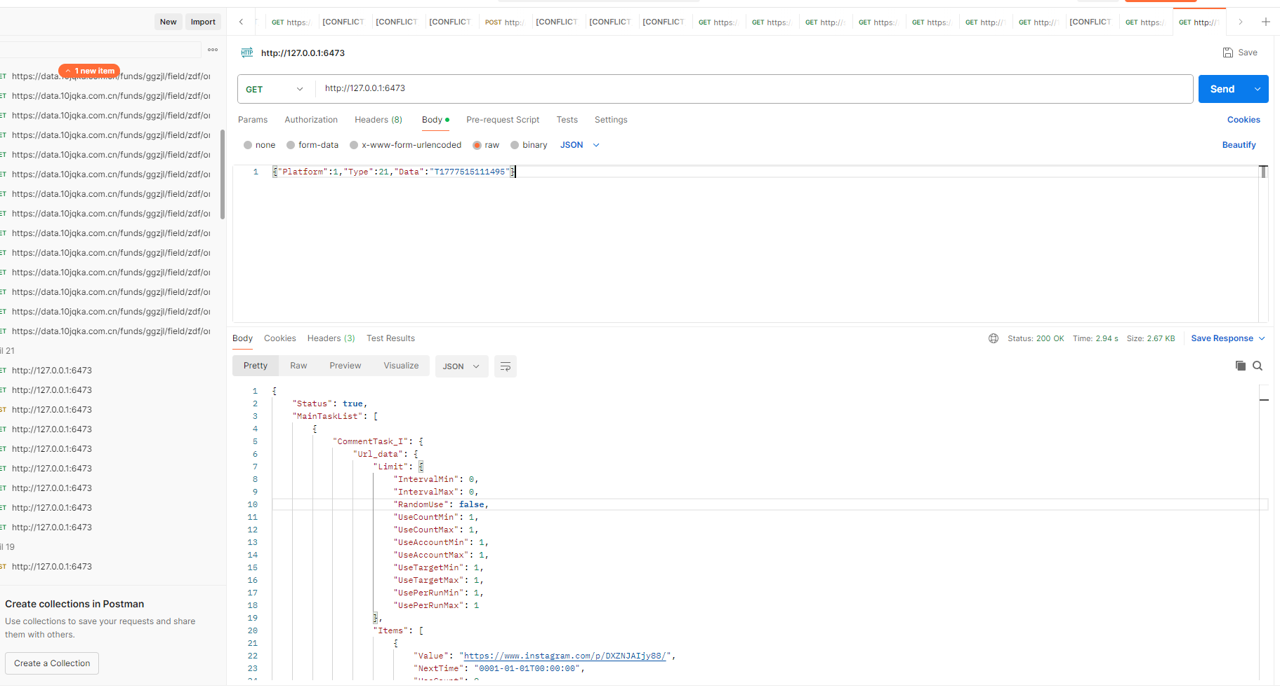
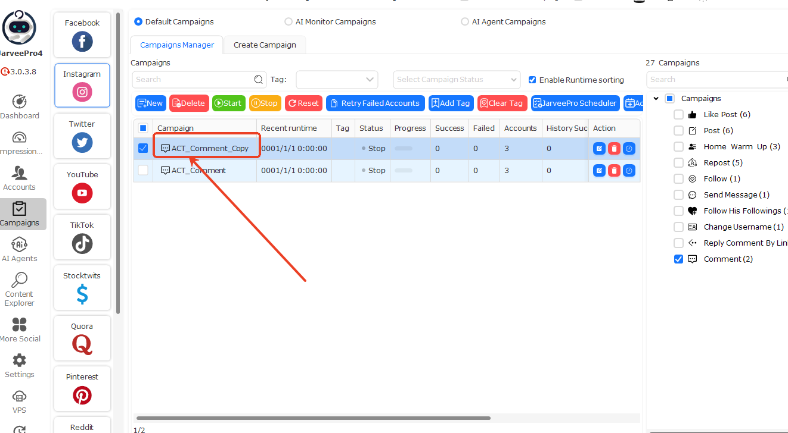
4. Based on this task data, modify the task data that we want to execute. The returned data is as follows.
{
"Status": true,
"MainTaskList": [
{
"CommentTask_I": {
"Url_data": {
"Limit": {
"IntervalMin": 0,
"IntervalMax": 0,
"RandomUse": false,
"UseCountMin": 1,
"UseCountMax": 1,
"UseAccountMin": 1,
"UseAccountMax": 1,
"UseTargetMin": 1,
"UseTargetMax": 1,
"UsePerRunMin": 1,
"UsePerRunMax": 1
},
"Items": [
{
"Value": "https://www.instagram.com/p/DXZNJAIjy88/",
"NextTime": "0001-01-01T00:00:00",
"UseCount": 0,
"AccountUseCount": {},
"TargetUseCount": {}
},
{
"Value": "https://www.instagram.com/p/DXtvzoHDse5/",
"NextTime": "0001-01-01T00:00:00",
"UseCount": 0,
"AccountUseCount": {},
"TargetUseCount": {}
},
{
"Value": "https://www.instagram.com/p/DXEggDKAVza/",
"NextTime": "0001-01-01T00:00:00",
"UseCount": 0,
"AccountUseCount": {},
"TargetUseCount": {}
}
],
"ListData": false,
"Probability": 100,
"Count": 3
},
"Comment_data": {
"Limit": {
"IntervalMin": 0,
"IntervalMax": 0,
"RandomUse": false,
"UseCountMin": 1,
"UseCountMax": 1,
"UseAccountMin": 1,
"UseAccountMax": 1,
"UseTargetMin": 1,
"UseTargetMax": 1,
"UsePerRunMin": 1,
"UsePerRunMax": 1
},
"Items": [
{
"Value": "Hi good",
"NextTime": "0001-01-01T00:00:00",
"UseCount": 0,
"AccountUseCount": {},
"TargetUseCount": {}
},
{
"Value": "wow",
"NextTime": "0001-01-01T00:00:00",
"UseCount": 0,
"AccountUseCount": {},
"TargetUseCount": {}
},
{
"Value": "very good",
"NextTime": "0001-01-01T00:00:00",
"UseCount": 0,
"AccountUseCount": {},
"TargetUseCount": {}
}
],
"ListData": false,
"Probability": 100,
"Count": 3
},
"commentUrlSave": {
"SaveToFile": false,
"JoinString": "\\r\\n",
"FilePath": ""
}
},
"Results": [],
"AutoTryNum": 0,
"StartTime": "0001-01-01T00:00:00",
"StopTime": "0001-01-01T00:00:00",
"IsMcsTask": false,
"IsPublicMcsTask": false,
"IsSmallData": true,
"Tag": "",
"PlanId": "",
"IsSubsidiary": false,
"SubsidiaryTaskType": 0,
"TimeMin": 0,
"TimeMax": 0,
"NextTime": "0001-01-01T00:00:00",
"PlanCount": 0,
"Id": "T1777519775783",
"Name": "ACT_Comment_Copy",
"TaskType": 39,
"PlatformType": 1,
"AccountList": {
"Limit": {
"IntervalMin": 0,
"IntervalMax": 0,
"RandomUse": false,
"UseCountMin": 1,
"UseCountMax": 1,
"UseAccountMin": 1,
"UseAccountMax": 1,
"UseTargetMin": 1,
"UseTargetMax": 1,
"UsePerRunMin": 1,
"UsePerRunMax": 1
},
"Items": [
{
"Value": "A1743661991928",
"NextTime": "0001-01-01T00:00:00",
"UseCount": 0,
"AccountUseCount": {},
"TargetUseCount": {}
},
{
"Value": "A1743661992108",
"NextTime": "0001-01-01T00:00:00",
"UseCount": 0,
"AccountUseCount": {},
"TargetUseCount": {}
},
{
"Value": "A1766561433892",
"NextTime": "0001-01-01T00:00:00",
"UseCount": 0,
"AccountUseCount": {},
"TargetUseCount": {}
}
],
"ListData": false,
"Probability": 100,
"Count": 3
},
"Status": 0,
"Progress": 0.0,
"CreateTime": "2026-04-30T11:29:35.7986019+08:00",
"Finished": 0,
"failed": 0,
"IntervalEnabled": false,
"IntervalTimeMin": 0,
"IntervalTimeMax": 0,
"IsAiContent": false,
"currentSuccess": 0,
"currentFailed": 0,
"currentTotal": 0,
"Reset": false
}
]
}
The modified JSON data is attached below. For easier viewing, the formatted data is provided here. [Note: when finally passing the data, it needs to be compressed into a single line.]
{
"Platform": 1,
"Type": 20,
"Data": {
"CommentTask_I": {
"Url_data": {
"Limit": {
"IntervalMin": 0,
"IntervalMax": 0,
"RandomUse": false,
"UseCountMin": 1,
"UseCountMax": 1,
"UseAccountMin": 1,
"UseAccountMax": 1,
"UseTargetMin": 1,
"UseTargetMax": 1,
"UsePerRunMin": 1,
"UsePerRunMax": 1
},
"Items": [
{
"Value": "https://www.instagram.com/p/DT4nvkSgR70",
"NextTime": "0001-01-01T00:00:00",
"UseCount": 0,
"AccountUseCount": {},
"TargetUseCount": {}
},
{
"Value": "https://www.instagram.com/p/DXTh1Q9jxwT/",
"NextTime": "0001-01-01T00:00:00",
"UseCount": 0,
"AccountUseCount": {},
"TargetUseCount": {}
}
],
"ListData": false,
"Probability": 100,
"Count": 3
},
"Comment_data": {
"Limit": {
"IntervalMin": 0,
"IntervalMax": 0,
"RandomUse": false,
"UseCountMin": 1,
"UseCountMax": 1,
"UseAccountMin": 1,
"UseAccountMax": 1,
"UseTargetMin": 1,
"UseTargetMax": 1,
"UsePerRunMin": 1,
"UsePerRunMax": 1
},
"Items": [
{
"Value": "What this is his",
"NextTime": "0001-01-01T00:00:00",
"UseCount": 0,
"AccountUseCount": {},
"TargetUseCount": {}
},
{
"Value": "oh his to you people",
"NextTime": "0001-01-01T00:00:00",
"UseCount": 0,
"AccountUseCount": {},
"TargetUseCount": {}
}
],
"ListData": false,
"Probability": 100,
"Count": 3
},
"commentUrlSave": {
"SaveToFile": false,
"JoinString": "\\r\\n",
"FilePath": ""
}
},
"Results": [],
"AutoTryNum": 0,
"StartTime": "0001-01-01T00:00:00",
"StopTime": "0001-01-01T00:00:00",
"IsMcsTask": false,
"IsPublicMcsTask": false,
"IsSmallData": true,
"Tag": "",
"PlanId": "",
"IsSubsidiary": false,
"SubsidiaryTaskType": 0,
"TimeMin": 0,
"TimeMax": 0,
"NextTime": "0001-01-01T00:00:00",
"PlanCount": 0,
"Id": "T1777519775783",
"Name": "Test_Comment",
"TaskType": 39,
"PlatformType": 1,
"AccountList": {
"Limit": {
"IntervalMin": 0,
"IntervalMax": 0,
"RandomUse": false,
"UseCountMin": 1,
"UseCountMax": 1,
"UseAccountMin": 1,
"UseAccountMax": 1,
"UseTargetMin": 1,
"UseTargetMax": 1,
"UsePerRunMin": 1,
"UsePerRunMax": 1
},
"Items": [
{
"Value": "A1743661991928",
"NextTime": "0001-01-01T00:00:00",
"UseCount": 0,
"AccountUseCount": {},
"TargetUseCount": {}
},
{
"Value": "A1743661992108",
"NextTime": "0001-01-01T00:00:00",
"UseCount": 0,
"AccountUseCount": {},
"TargetUseCount": {}
},
{
"Value": "A1766561433892",
"NextTime": "0001-01-01T00:00:00",
"UseCount": 0,
"AccountUseCount": {},
"TargetUseCount": {}
}
],
"ListData": false,
"Probability": 100,
"Count": 3
},
"Status": 0,
"Progress": 0,
"CreateTime": "2026-04-30T11:29:35.7986019+08:00",
"Finished": 0,
"failed": 0,
"IntervalEnabled": false,
"IntervalTimeMin": 0,
"IntervalTimeMax": 0,
"IsAiContent": false,
"currentSuccess": 0,
"currentFailed": 0,
"currentTotal": 0,
"Reset": false
}
}
The compressed JSON data for the request is:
{"Platform":1,"Type":20,"Data":{"CommentTask_I":{"Url_data":{"Limit":{"IntervalMin":0,"IntervalMax":0,"RandomUse":false,"UseCountMin":1,"UseCountMax":1,"UseAccountMin":1,"UseAccountMax":1,"UseTargetMin":1,"UseTargetMax":1,"UsePerRunMin":1,"UsePerRunMax":1},"Items":[{"Value":"https://www.instagram.com/p/DT4nvkSgR70","NextTime":"0001-01-01T00:00:00","UseCount":0,"AccountUseCount":{},"TargetUseCount":{}},{"Value":"https://www.instagram.com/p/DXTh1Q9jxwT/","NextTime":"0001-01-01T00:00:00","UseCount":0,"AccountUseCount":{},"TargetUseCount":{}}],"ListData":false,"Probability":100,"Count":3},"Comment_data":{"Limit":{"IntervalMin":0,"IntervalMax":0,"RandomUse":false,"UseCountMin":1,"UseCountMax":1,"UseAccountMin":1,"UseAccountMax":1,"UseTargetMin":1,"UseTargetMax":1,"UsePerRunMin":1,"UsePerRunMax":1},"Items":[{"Value":"What this is his","NextTime":"0001-01-01T00:00:00","UseCount":0,"AccountUseCount":{},"TargetUseCount":{}},{"Value":"oh his to you people","NextTime":"0001-01-01T00:00:00","UseCount":0,"AccountUseCount":{},"TargetUseCount":{}}],"ListData":false,"Probability":100,"Count":3},"commentUrlSave":{"SaveToFile":false,"JoinString":"\\r\\n","FilePath":""}},"Results":[],"AutoTryNum":0,"StartTime":"0001-01-01T00:00:00","StopTime":"0001-01-01T00:00:00","IsMcsTask":false,"IsPublicMcsTask":false,"IsSmallData":true,"Tag":"","PlanId":"","IsSubsidiary":false,"SubsidiaryTaskType":0,"TimeMin":0,"TimeMax":0,"NextTime":"0001-01-01T00:00:00","PlanCount":0,"Id":"T1777519775783","Name":"Test_Comment","TaskType":39,"PlatformType":1,"AccountList":{"Limit":{"IntervalMin":0,"IntervalMax":0,"RandomUse":false,"UseCountMin":1,"UseCountMax":1,"UseAccountMin":1,"UseAccountMax":1,"UseTargetMin":1,"UseTargetMax":1,"UsePerRunMin":1,"UsePerRunMax":1},"Items":[{"Value":"A1743661991928","NextTime":"0001-01-01T00:00:00","UseCount":0,"AccountUseCount":{},"TargetUseCount":{}},{"Value":"A1743661992108","NextTime":"0001-01-01T00:00:00","UseCount":0,"AccountUseCount":{},"TargetUseCount":{}},{"Value":"A1766561433892","NextTime":"0001-01-01T00:00:00","UseCount":0,"AccountUseCount":{},"TargetUseCount":{}}],"ListData":false,"Probability":100,"Count":3},"Status":0,"Progress":0,"CreateTime":"2026-04-30T11:29:35.7986019+08:00","Finished":0,"failed":0,"IntervalEnabled":false,"IntervalTimeMin":0,"IntervalTimeMax":0,"IsAiContent":false,"currentSuccess":0,"currentFailed":0,"currentTotal":0,"Reset":false}}
The final result is shown in the figure below, where we can see the modified data：
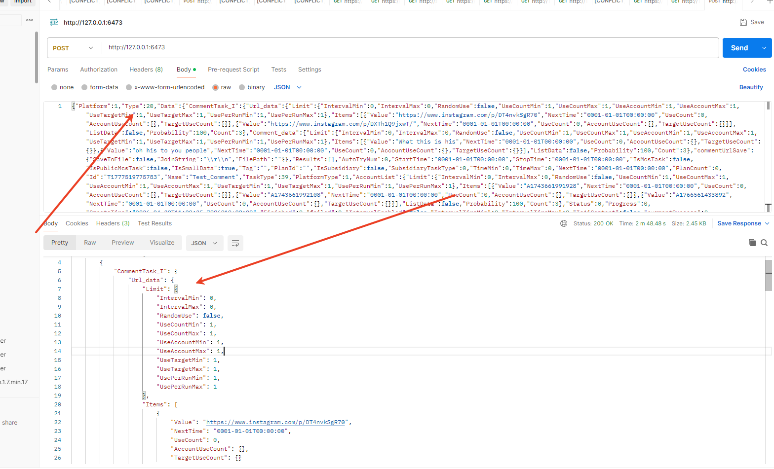

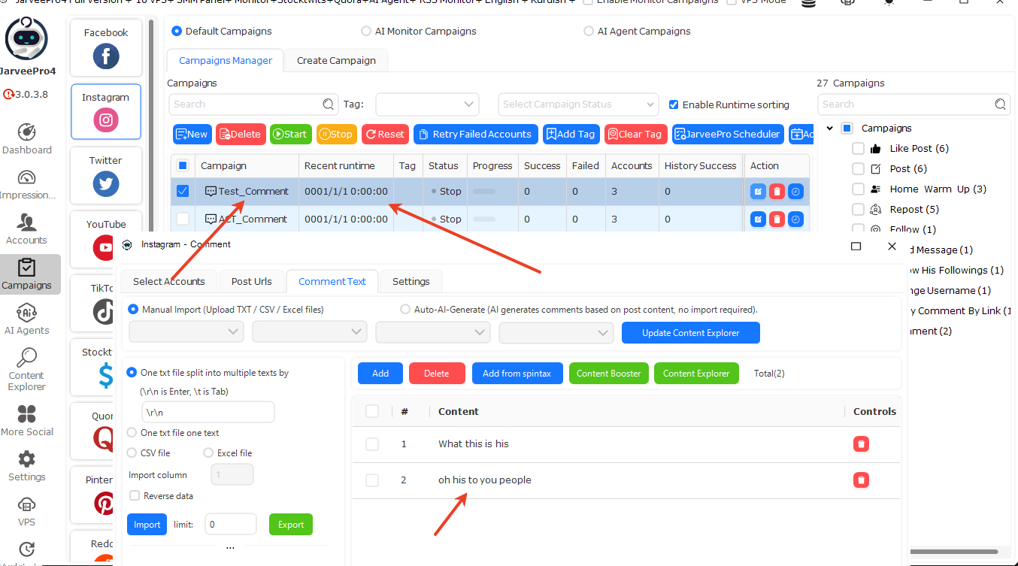
Next, we can run this task, as shown in the figure below:
